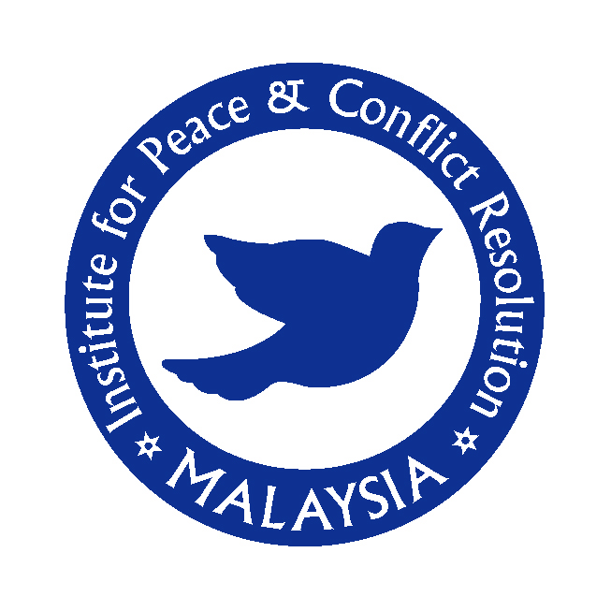

INSTITUTE FOR PEACE AND CONFLICT RESOLUTION

MALAYSIA

(IPCR)




*************************************************************

INSTITUTE FOR PEACE AND CONFLICT RESOLUTION

MALAYSIA

ADDRESS: Institute for Peace & Conflict Resolution

Suite 19A-19-5, Level 19, UOA Centre

No: 19 Jalan Pinang, 50450 Kuala Lumpur, Malaysia

TELEPHONE: + 603 2166 4725

FAX: + 603 2166 4736

EMAIL: ipcr@stratad.net

HONOURY PATRON: To Be Appointed

BOARD OF DIRECTORS: Andrin Raj – Executive Director

Nazim Bin Abdul Aziz - Managing Director

William Ong – Director

INSTITUTE FOR PEACE AND CONFLICT RESOLUTION (IPCR)

Mission Statement:

To Promote Peace and Security in the International Global Environment

The Institute’s Logo & Symbol:

The blue circle depicts unity within the nations and the dove symbolizes peace and security for humanity

IPCR Introduction
The Institute conducts independent research on peace and security studies in the region and shares its findings with policy makers and the public. The Institute is a Non Governmental Organization and a Not for Profit Organization. It provides a forum for discussion with the strategic community on strategic issues and strives to explore alternatives. Moreover, it works towards building capacity among young scholars for greater refinement of their analyses of South Asian peace and conflict issues.

Through close interaction with leading strategic thinkers, former members of the Administrative Service, the Foreign Service and the Armed Forces, the academic community as well as the media are associated with IPCR and its endeavor towards its core objectives in peace and conflict studies. IPCR in collaboration with Stratad Asia Pacific Strategic Centre is part of the founding members of the TOD TURKEY – Think Tank Organization Dialogue of Turkey with its setting of the Strategic Communications Network, spearheaded by Turkish Asian Center For Strategic Studies (TASAM) based in Turkey with an association of 23 nations’ top strategic centres from Central Europe, Middle East and Asia, with the core perspective on “Civilization and Peace”.
The primary objective of the IPCR is to chalk out a comprehensive framework for peace and conflict studies and security within its framework, one which caters to the changing demands of national, regional and global peace and security. Apart from analyzing the existing approaches to security, peace, and world order, IPCR has made a foray into evolving alternative approaches to the aforesaid issues, to promote a harmonious and secured regional and global order. More specifically, the IPCR focuses on:

- Peace and Conflict Resolution studies
- Peace and security through disarmament
- Regional Cooperation in Southeast Asia for peace and security
- Poverty Eradication and Humanitarian studies
- Middle East Peace studies
- Southern Thailand Conflict Studies and resolution
- African Union Security, Peace and Conflict Resolution
- European & US relations with NAM states
- Confidence Building Measures
- Civil Military Relations & Peacekeeping
- Human Security
- Environmental studies
- Risk & Disaster Management
- Non-military Threats to Security
- Education
- Political Violence and Terrorism
- South and Southeast Asian Security
- Information Society & Media Relations
- Social Responsibility & Governance
- Political & International Relations

Commitment to Independence
IPCR is dedicated to independent, non-partisan research and analysis. While IPCR aims to receive funding from various government agencies and private sources worldwide, its policy recommendations do not subscribe to any particular views or interest.
Projects
IPCR carries out vital *projects on contemporary international affairs, dedicated to the study of peace and security and will be funded by philanthropic organizations, government organizations and private companies.
- Currently carried out by our strategic cooperation partners.
Publications
- IPCR will publish and distribute a quarterly bulletin Peace & Security containing select documents, opinion articles and seminar reports from the Member Think Tanks groups to opinion makers in Malaysia and abroad on restricted basis. IPCR will publish scholarly research monographs and books authored and edited by the members of its group.

Honourary Patron
- To be appointed

- Board of Directors
- Andrin Raj
- William Ong
- Azrul Nazim Bin Abdul Aziz

Executive Advisory Committee Members (Non –Director)
- Dr. Rohan Gunaratna – Centre For Political Violence and Terrorism Studies, Nanyang Technological University, Singapore
- Tan Sri Dato’ (Dr) R.V. Navartnam – Transparency International, Malaysia
- Dato’ Dr. Ir. Ian Chia – United Nations Association of Malaysia
- K.S. Balakrishnan- Department of Strategic and International Studies, University Malaya
- Dr. Richard Mason - Institute of Occidental Studies, National University Malaysia

Special Advisors
- Mike Musaka – Institute for Security Studies, Ethiopia
- Shrikant Menjoge – Strategic Foresight Group, India
- Lt. Col. Sani Royan – Ministry of Defence Malaysia

Advocates & Solicitors
- S.S. Ruben & Associates

Adjunct Fellows - Advisory Committee Members
- Ambassador Murat Bilhan
Turkish Asian Center For Strategic Studies (TASAM), Turkey
- Dr. Taha Abdel Alem
Al-Ahram Center for Political and Strategic Studies, Egypt
- Dr. Konstantin A. Kokarev
Russia’s Institute For Strategic Studies, Russia
- Ambassador Bisera Turkovic’, PhD
Embassy of Bosnia & Herzegovina, United States of America Centre for Security Studies, Bosnia
- Dr. Mansown Abdullah Al-Mansour
Center For Strategic Studies, Kingdom of Saudi Arabia
- Oraib Al-Rantawi
Al- Quds Center For Political Studies, Jordan
- Kamil B. Raif
Center for Strategic Studies, Turkey
- Ambassador Toshiyuki Fujiwara
The Japan Institute of International Studies, Japan
  - Prof. Yang Guang
Institute of West-Asian & African Studies, Chinese Academy of Social Sciences, China

<<<<<<<<<<<<<<<<<<<<<<<<<<<<<<<<>>>>>>>>>>>>>>>>>>>>>>>>>>>>>>………………………………………………………………………………………………
ICPR ICPR ICPR ICPR ICPR ICPR ICPR ICPR ICPR ICPR ICPR ICPR ICPR ICPR ICPR ICPR ICPR ICPR ICPR

INSTITUTE FOR PEACE AND CONFLICT RESOLUTION
Suite 19A-19-5, Level 19, UOA Centre, No: 19 Jalan Pinang,
50450 Kuala Lumpur, Malaysia
Tel: + 603 2166 4725 Fax + 603 2166 4726
Email: ipcr@stratad.net

